Day 8: 21 Sep. 25

Creating simple REST full Web service with Products array variables

Create the folder as SimpleRestAPI
npm init -y package.json
npm install express
Open the folder inside a VS Code

mongodb : mongodb is another external native module provided by node js which help to connect mongo db database using node js program. Using node js / express js we can store, delete, update and retrieve documents from mongo db database.
mysql : mysql is node js external module which help to connect mysql database using node js as well as express js.

Create a folder with name as product-restapi-with-mongodb
npm init -y
npm install express mongodb
then open the project in VS code

Creating Rest API for Product with Array concept or file or database.
Array concept
- Get method : get the resources
  - Get all product in json format : select query
  - Get particular product base upon some property like pid, pname, price
    - Query param
URL?key=value
URL?key1=value1&key2=value2
    - Path param
URL/value
URL/value1/value2

Select query with where clause

- Post method : create the resource
  - store the product details in array or file system or database
insert query
Post method data send through body part in different format like json or xml etc.

By default express js can’t extract body data from request object we need to use middleware.

Testing through post man client

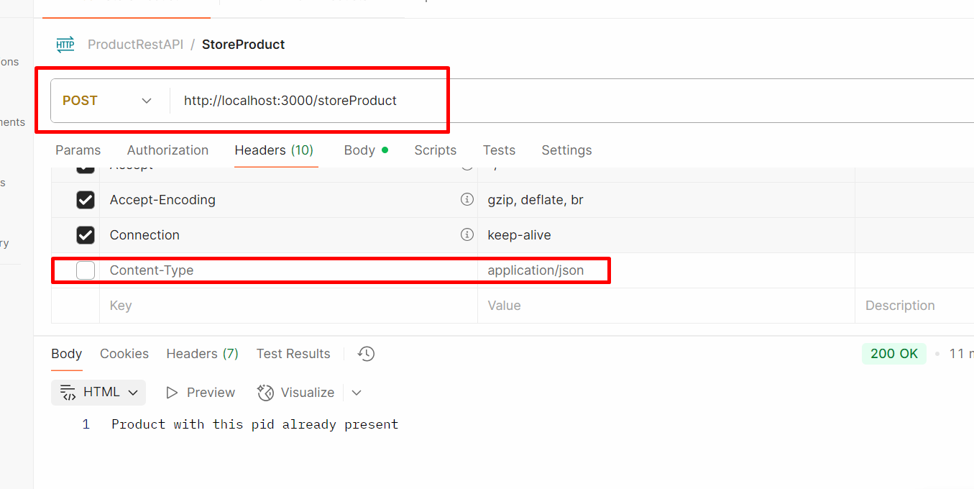

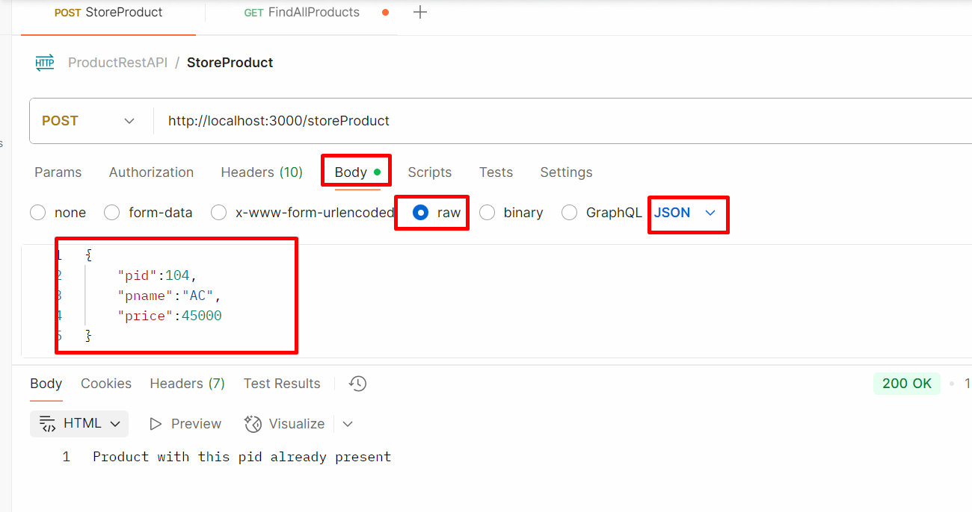

- Put method : update the existing resource
  - Update the product price using pid
Update query

- Delete method : delete the resource
  - Delete the product using pid
Delete query

To test these end or rest api we need some rest api plugin.
Post Man plugin
Only Get method we can test through browser.

Creating REST API for product object with array concept
Create the folder product-rest-api
npm init -y create the package.json file
npm install express

